**PF LAB- 05**

**“ Nested if-else, Nested structures & Operators ”**

***By Fizza Batool [24k-0587]***

****

**#include <stdio.h>**

**int main() {**

**int age;**

**printf("Enter your age:");**

**scanf("%d",&age);**

**if(age>=0 && age<=120) {**

**if(age>=0 && age<=12){**

**printf("This person is a child!");**

**} else if(age>=13&&age<=19) {**

**printf("This person is a teenager!");**

**} else if(age>=20&&age<=60) {**

**printf("This person is an adult!");**

**} else if (age>=61&&age<=120) {**

**printf("This person is a senior!");**

**}**

**} else {**

**printf("Your age is invalid!, please enter a valid age");**

**}**

**return 0;**

**}**

**C:\Users\hp\AppData\Local\Packages\5319275A.WhatsAppDesktop_cv1g1gvanyjgm\TempState\8D0EC730B0D5671646E4D7828A69D534\WhatsApp Image 2024-09-29 at 21.21.34_322a8346.jpg**

**C:\Users\hp\AppData\Local\Packages\5319275A.WhatsAppDesktop_cv1g1gvanyjgm\TempState\44CD7D4F05CD775B99D2F68B169D2764\WhatsApp Image 2024-09-29 at 21.21.35_11d0289b.jpg**

**C:\Users\hp\AppData\Local\Packages\5319275A.WhatsAppDesktop_cv1g1gvanyjgm\TempState\CA47D49B363EF094BA80BD0B8C4E04B5\WhatsApp Image 2024-09-29 at 21.21.35_48b51c67.jpg**

**C:\Users\hp\AppData\Local\Packages\5319275A.WhatsAppDesktop_cv1g1gvanyjgm\TempState\2E5CC5258C6FE155A7FD1C520F0AF756\WhatsApp Image 2024-09-29 at 21.21.36_4d39664e.jpg**

**C:\Users\hp\AppData\Local\Packages\5319275A.WhatsAppDesktop_cv1g1gvanyjgm\TempState\2F5D21999DA313309846DB2CF8F995DF\WhatsApp Image 2024-09-29 at 21.21.35_de427dd3.jpg**

****

**#include<stdio.h>**

**int main () {**

**int num1, num2;**

**printf("Enter your first number: \n");**

**scanf("%d",&num1);**

**printf("Enter your second number: \n");**

**scanf("%d",&num2);**

**num1>num2 ? printf("your first number is greater than second number") : printf("your second number is greater than first number");**

**return 0;**

**}**

**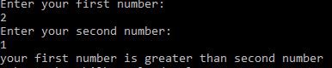**

****

**#include<stdio.h>**

**int main() {**

**int num;**

**printf("Enter your number: ");**

**scanf("%d",&num);**

**if(num%3==0 && num%5==0) {**

**printf("Your number is divisible by both 3 and 5");**

**} else {**

**printf("Your number is not divisible by 3 and 5");**

**}**

**return 0;**

**}**

**C:\Users\hp\AppData\Local\Microsoft\Windows\INetCache\IE\LUCCFJER\div1[1].PNG**

**C:\Users\hp\AppData\Local\Microsoft\Windows\INetCache\IE\OPMYVSD3\div2[1].PNG**

****

**#include<stdio.h>**

**int main () {**

**int age,nat\_code;**

**printf("Enter your age: \n");**

**scanf("%d",&age);**

**printf("Enter your nationality (1 for indian, 2 for pakistani, 3 for other); \n");**

**scanf("%d",&nat\_code);**

**if(age>=18 && nat\_code==2 ) {**

**printf("You are eligible to vote!");**

**} else {**

**printf("You are not eligible to vote as you do not meet all the requirements! ");**

**}**

**return 0;**

**}**

**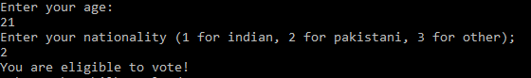**



**#include<stdio.h>**

**int main () {**

**int num1, num2;**

**printf("Enter your first number: \n");**

**scanf("%d",&num1);**

**printf("Enter your second number: \n");**

**scanf("%d",&num2);**

**num1>num2 ? printf("your first number is greater than second number") : printf("your second number is greater than first number");**

**return 0;**

**}**

**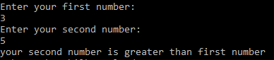**



**#include<stdio.h>**

**int main() {**

**int num;**

**printf("Enter you number: \n");**

**scanf("%d",&num);**

**if(num==0) {**

**printf("Your number is zero");**

**} else {**

**num>0 ? printf("Your number is a positive number") : printf("Your number is a negative number");**

**}**

**return 0;**

**}**

**C:\Users\hp\AppData\Local\Microsoft\Windows\INetCache\IE\LUCCFJER\ter_0[1].PNG**

**C:\Users\hp\AppData\Local\Microsoft\Windows\INetCache\IE\OPMYVSD3\ter_neg[1].PNG**

**C:\Users\hp\AppData\Local\Microsoft\Windows\INetCache\IE\GOVMBEJQ\ter_pos[1].PNG**

****

**#include<stdio.h>**

**int main() {**

**int a, b;**

**printf("Enter first number: \n");**

**scanf("%d",&a);**

**printf("Enter second number: \n");**

**scanf("%d",&b);**

**printf("Before swapping \n a=%d \n b=%d \n",a,b);**

**a=a^b ;**

**b=a^b ;**

**a=a^b ;**

**printf("Ater swapping \n a=%d \n b=%d", a,b);**

**return 0;**

**}**

**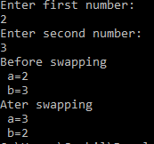**

****

**#include<stdio.h>**

**int main () {**

**int year;**

**printf("Enter your year:\n");**

**scanf("%d",&year);**

**if( year%4==0 && year%100!=0 || year%400==0) {**

**printf(" Your year is a leap year!");**

**} else {**

**printf(" Your year is not a leap year!");**

**}**

**return 0;**

**}**

**C:\Users\hp\AppData\Local\Microsoft\Windows\INetCache\IE\OPMYVSD3\year[1].PNG**

**C:\Users\hp\AppData\Local\Packages\5319275A.WhatsAppDesktop_cv1g1gvanyjgm\TempState\68722B092586CF1D41E07BB366C760C6\WhatsApp Image 2024-09-29 at 21.07.23_f5d09578.jpg**

****

**#include<stdio.h>**

**int main () {**

**int num1, num2, num3 ;**

**printf("Enter your first number: \n");**

**scanf("%d",&num1);**

**printf("Enter your second number: \n");**

**scanf("%d",&num2);**

**printf("Enter your third number: \n");**

**scanf("%d",&num3);**

**if(num1>num2) {**

**if(num1>num3) {**

**printf("First number is the greatest among three numbers !");**

**} else {**

**printf("third number is the greatest among three numbers !");**

**}**

**}else {**

**if(num2>num3) {**

**printf("Second number is the greatest among three numbers !");**

**} else {**

**printf("Third number is the greatest among three numbers !");**

**}**

**}**

**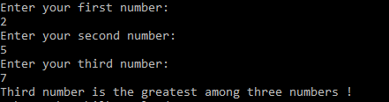return 0;**

**}**

****

**#include <stdio.h>**

**int main() {**

**float att;**

**float asg1, asg2, asg3, asg4, asg5;**

**float marks1, marks2, marks3, marks4, marks5;**

**float Tasg, Tmarks, totalScore;**

**printf("Enter your attendance as percentage: \n");**

**scanf("%f", &att);**

**printf("Enter your total PF assignment marks as percentage: \n");**

**scanf("%f", &asg1);**

**printf("Enter your total CAG assignment marks as percentage: \n");**

**scanf("%f", &asg2);**

**printf("Enter your total FE assignment marks as percentage: \n");**

**scanf("%f", &asg3);**

**printf("Enter your total AP assignment marks as percentage: \n");**

**scanf("%f", &asg4);**

**printf("Enter your total ICP assignment marks as percentage: \n");**

**scanf("%f", &asg5);**

**printf("Enter your mid+final exam score of PF as a percentage: \n");**

**scanf("%f", &marks1);**

**printf("Enter your mid+final exam score of CAG as a percentage: \n");**

**scanf("%f", &marks2);**

**printf("Enter your mid+final exam score of FE as a percentage: \n");**

**scanf("%f", &marks3);**

**printf("Enter your mid+final exam score of AP as a percentage: \n");**

**scanf("%f", &marks4);**

**printf("Enter your mid+final exam score of ICP as a percentage: \n");**

**scanf("%f", &marks5);**

**Tasg = asg1 + asg2 + asg3 + asg4 + asg5;**

**Tmarks = marks1 + marks2 + marks3 + marks4 + marks5;**

**totalScore = (Tasg / 5 \* 0.20) + (Tmarks / 5 \* 0.80);**

**if (att >= 75 && att<=100) {**

**if (totalScore>= 90 && totalScore<=100) {**

**printf("You passed the semester with the overall grade 'A\*'!\n");**

**} else if (totalScore >= 80 && totalScore<=89) {**

**printf("You passed the semester with the overall grade 'A'!\n");**

**} else if (totalScore >= 70 && totalScore<=79) {**

**printf("You passed the semester with the overall grade 'B'!\n");**

**} else if (totalScore >= 60 && totalScore<=69) {**

**printf("You passed the semester with the overall grade 'C'!\n");**

**} else if (totalScore >= 50 && totalScore<=59) {**

**printf("You passed the semester with the overall grade 'D'!\n");**

**} else {**

**printf("Sorry! You could not pass the semester due to low marks.\n");**

**}**

**} else {**

**printf("Your attendance doesn't meet the requirement to pass this semester.\n");**

**}**

**return 0;**

**}**

**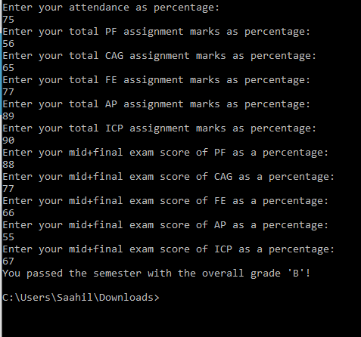**



**#include <stdio.h>**

**int main( ){**

**char A,B,C;**

**printf("Enter your character: ");**

**scanf(" %c",&A);**

**B=A^1;**

**C=B^1;**

**printf ("Encryption is %c",B);**

**printf ("\nDecryption is %c",C);**

**}**

**C:\Users\hp\AppData\Local\Microsoft\Windows\INetCache\IE\GOVMBEJQ\enc[1].PNG**

****

**#include <stdio.h>**

**int main() {**

**int age;**

**float income;**

**int CreditScore;**

**printf("Enter your age: ");**

**scanf("%d", &age);**

**printf("Enter your monthly income in rupees: ");**

**scanf("%f", &income);**

**printf("Enter your credit score in rupees: ");**

**scanf("%d", &CreditScore);**

**if (age >= 18 && income >=70000 && CreditScore >= 10000) {**

**printf("You are eligible for the loan.\n");**

**} else {**

**printf("You are not eligible for the loan.\n");**

**}**

**return 0;**

**}**

**